LAB EXPERIMENT RECORD

Set 4: Product Inventory Analysis

Department | AIDS
Course Code / Course Name | DSA0602 / Data Handling and Visualization
Experiment | Data Visualization using R
Name | GOPIKHA S
Register Number | 1924260143
Date | 1 October 2026
Day | Thursday

Dataset: Product Inventory

Product ID | Product Name | Quantity Available | Product Category | Price
1 | Product A | 250 | Category 1 | 50
2 | Product B | 175 | Category 2 | 80
3 | Product C | 300 | Category 1 | 40
4 | Product D | 200 | Category 2 | 70
5 | Product E | 220 | Category 1 | 60
Note: Product Category and Price are example fields added because they are required for Programs 2 and 3.

To create a bar chart to visualize the quantity of each product in the inventory with appropriate labels and title.

R Program
product_name <- c("Product A", "Product B", "Product C", "Product D", "Product E") quantity <- c(250, 175, 300, 200, 220)
inventory <- data.frame(product_name, quantity) barplot(
inventory$quantity,
names.arg = inventory$product_name, main = "Product Inventory Quantity", xlab = "Product Name",
ylab = "Quantity Available", col = "lightblue",
ylim = c(0, max(inventory$quantity) + 50)
)

text(
x = seq_along(inventory$quantity), y = inventory$quantity,
labels = inventory$quantity, pos = 3
)

OUTPUT

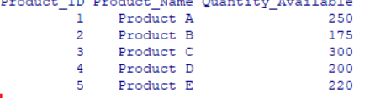

Observation
The bar chart shows the quantity available for each product. Product C has the highest quantity at 300 units, while Product B has the lowest quantity at 175 units.

To generate a stacked bar chart to show the quantity of each product within different product categories.

R Program
product_name <- c("Product A", "Product B", "Product C", "Product D", "Product E") category <- c("Category 1", "Category 2", "Category 1", "Category 2", "Category 1")
quantity <- c(250, 175, 300, 200, 220)
inventory <- data.frame(product_name, category, quantity) category_data <- matrix(
c(250, 0,
0, 175,
300, 0,
0, 200,
220, 0),
nrow = 5, byrow = TRUE
)

colnames(category_data) <- c("Category 1", "Category 2") rownames(category_data) <- inventory$product_name

barplot( t(category_data),
main = "Product Quantity by Category", xlab = "Product Name",
ylab = "Quantity Available",
col = c("lightgreen", "orange"), legend.text = TRUE
)

OUTPUT

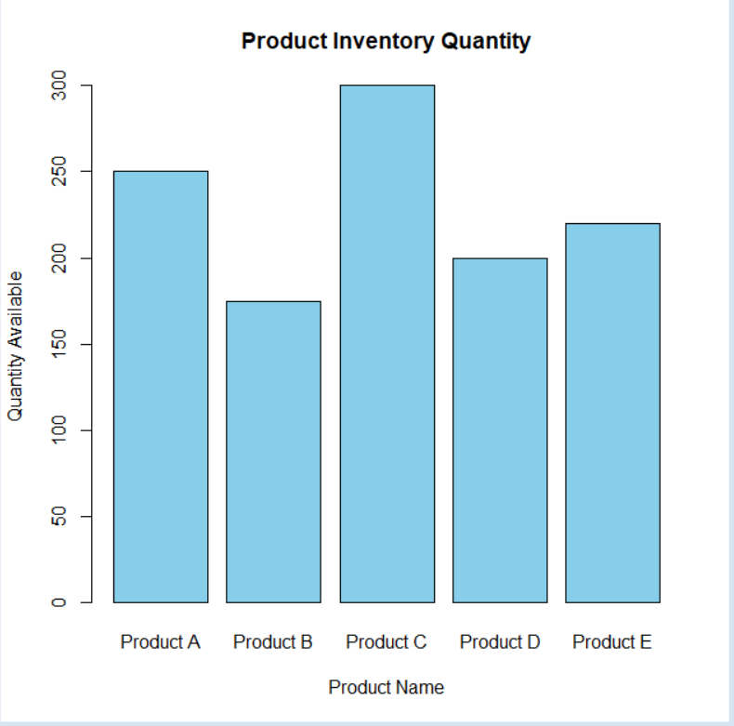

Observation
The stacked bar chart displays product quantities according to their categories. Category 1 contains Products A, C and E, while Category 2 contains Products B and D.

To build a scatter plot to explore the relationship between product price and quantity available.

R Program
product_name <- c("Product A", "Product B", "Product C", "Product D", "Product E") price <- c(50, 80, 40, 70, 60)
quantity <- c(250, 175, 300, 200, 220)
inventory <- data.frame(product_name, price, quantity) plot(
inventory$price, inventory$quantity,
main = "Product Price vs Quantity Available", xlab = "Product Price",
ylab = "Quantity Available", pch = 19,
col = "blue"
)

text( inventory$price, inventory$quantity,
labels = inventory$product_name, pos = 3
)

abline(lm(quantity ~ price, data = inventory), col = "red",
lwd = 2)

Output

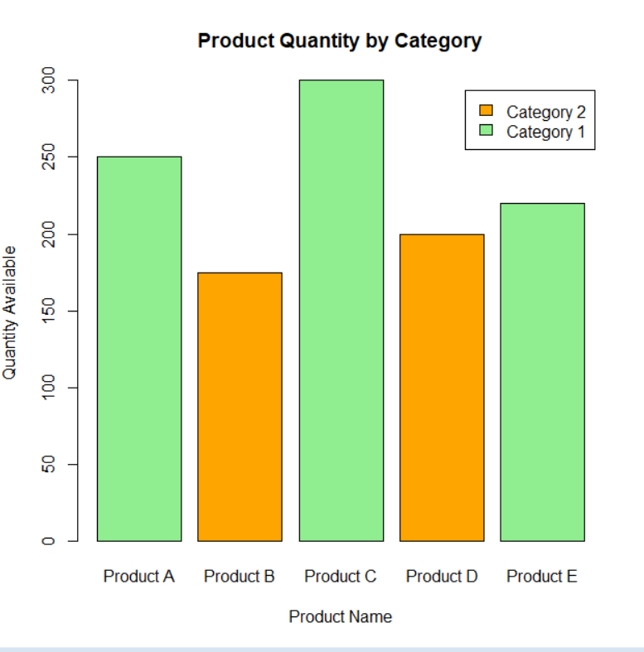

Observation
The scatter plot shows a generally negative relationship in this small dataset. Higher-priced products tend to have lower quantities available. Product B has the highest price of 80 and 175 units available, while Product C has the lowest price of 40 and 300 units available.

To develop an interactive Tableau dashboard containing the bar chart and stacked bar chart for product inventory analysis.
R Program
# 3. SCATTER PLOT
>
> plot(
+ inventory$Price,
+ inventory$Quantity_Available,
+ xlab = "Product Price",
+ ylab = "Quantity Available",
+ main = "Price vs Quantity Available",
+ pch = 19
+ )
>
> text(
+ inventory$Price,
+ inventory$Quantity_Available,
+ labels = inventory$Product_Name,
+ pos = 3
+ )

Procedure
Step 1: Open Tableau.
Step 2: Create the Product Inventory dataset in Excel/CSV with Product ID, Product Name, Quantity Available, Product Category and Price.
Step 3: Open Tableau → Connect to Data → select the Excel/CSV file. Step 4: Create Sheet 1 – Bar Chart.
- Drag Product Name → Columns.
- Drag Quantity Available → Rows.
- Select Bar Chart.
- Add title: Product Inventory Quantity.
Step 5: Create Sheet 2 – Stacked Bar Chart.
- Drag Product Name → Columns.
- Drag Quantity Available → Rows.
- Drag Product Category → Color.
- Select Bar Chart.
- Add title: Product Quantity by Category. Step 6: Create Dashboard.
- Click New Dashboard.
- Drag the Bar Chart onto the dashboard.
- Drag the Stacked Bar Chart beside or below it.
- Add title: Product Inventory Analysis Dashboard.
Step 7: Add filters/interaction
Expected dashboard
The dashboard allows users to visually explore:
- Quantity available for each product
- Product-wise inventory distribution
- Category-wise product quantities
- Interactive filtering by product and category

Overall Procedure
- Create/import the required Product Inventory dataset.
- Store the data in an R data frame.
- Create a bar chart for product quantities.
- Create a stacked bar chart for category-wise quantities.
- Create a scatter plot for product price versus quantity available.
- Add labels, titles, legends and a trend line where required.
- Import the dataset into Tableau.
- Create the bar chart and stacked bar chart in Tableau.
- Combine the charts into an interactive dashboard.
- Analyze the resulting visualizations.

The dashboard allows users to visually explore:
- Quantity available for each product
- Product-wise inventory distribution
- Category-wise product I by product and category

Overall Procedure
- Create/import the required Product Inventory dataset.
- Store the data in an R data frame
- Create a bar chart for product quantities.
- Create a stacked bar chart for category-wise quantities.
- Create a scatter plot for product price versus quantity available.
- Add labels, titles, legends and a trend line where required.
- Import the dataset into Tableau.
- Create the bar chart and stacked bar chart in Tableau.
- Combine the charts into an interactive dashboard.
- Analyze the resulting visualizations.

The product inventory quantities, category-wise quantities, and relationship between product price and quantity available were successfully visualized using R. An interactive Tableau dashboard was designed using the bar chart and stacked bar chart.

Key R Functions Used

Function | Purpose
c() | Create vectors
data.frame() | Create data frames
barplot() | Create bar and stacked bar charts
plot() | Create scatter plots
text() | Add labels to charts
lm() | Create a linear regression model
abline() | Add a regression/trend line

